**Earthquake Rescue Robot Coordinator**

**Name**: Sahil Kumar  
**Roll No**: ME24I1009  
**Date**: 24/04/2025  
**Course**: EDSA (Efficient Data Structures and Algorithms)

**1. Objective of the Assignment**

The aim set with this assignment is to create a simulated environment of an Earthquake Rescue Robot Coordinator system. This particular system is responsible for the management of robotics tasks, the handling of urgent missions, monitoring robotic activity, as well as logging activities into a mission register. The simulation is based upon basic data structures such as queues, stacks, arrays, singly linked lists, doubly linked lists, and circular linked lists for their application in implementing the principles of data structures.

**2. Design and Rationale of Data Structures**

Queue (Mission Request System): A queue is ideal for processing mission requests because it follows the First-In-First-Out (FIFO) strategy, which is useful for attending to rescue tasks in the order they are received.

Stack (Urgent Task Handler): A stack was chosen for urgent tasks because of its Last-In-First-Out (LIFO) characteristics. The most pressing emergency must be dealt with first—not to be stubborn, but because that is how LIFO works.

Array (Rescue Log Unit): An array of fixed size is implemented for mission logging in order to simulate coping with insufficient available memory. It cyclically overwrites old entries so that recent tasks are always available.

Singly Linked List (Damaged Robot Tracker): This linked structure facilitates the tracking of damaged robots by allowing dynamic insertion without having to relocate memory.

Doubly Linked List (Repaired Robot Inspection): Allows forwards and backwards movement for all inspected repaired robots for thorough inspection rout in.  
Circular Linked List (Priority Redeployment): Assigned to robots who require constant urgent

redeployment. Its circular form enables uninterrupted movement around the list.

**3. Implementation Logic and Functions**

**• enqueue(), dequeue():** Oversee the queue of rescue missions. Enqueue adds new tasks, and dequeue fetches the next mission.





**•push(), pop():** Control the management of urgent tasks as a stack. Push adds more emergencies, but pop releases them for immediate retrieval**.**

**• logMission(), displayLog():** Append missions to a fixed-sized array and overwrite the oldest mission when full.

**• insert Damaged Robot(), deleteDamaged Robot() :** Maintain and repair damaged robots.



**• insertRepairedRobot(), forwardTraversal(), backwardTraversal():** Control the movement and inspection of repaired robots in a doubly linked list.



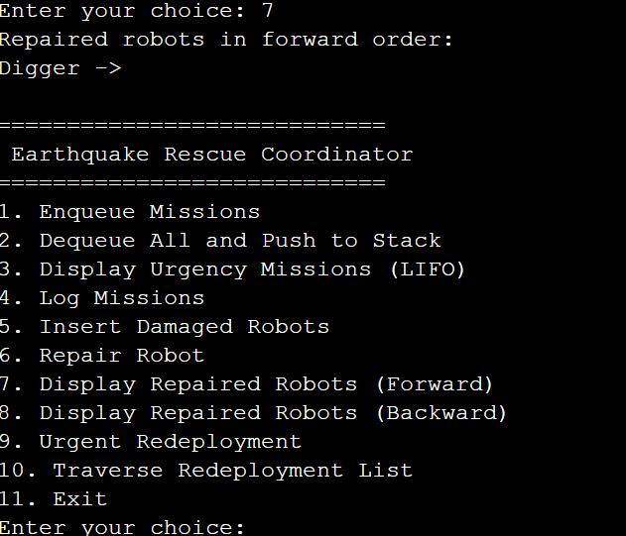

**• redeployDamagedRobot(), traverseCircular():** Manage the urgent need for redeployment through circular linked lists.





**4. Functionality Breakdown**

**• Batching Operations (Queue + stack)**

1. Order 6 missions sequentially.

2. Remove all from queue and place into a stack for storage.

3. Perform retrieval from the stack to address time-sensitive tasks.

**Creativity Bonus: Advanced Emergency Management Logic suggests “Cutter” is chronologically last to be inputted, making it the most urgent: leftover debris could block a rescue tunnel.**

**• Simulation of Logging (Array)**

* Record 8 missions in the 6-slot array, overwriting the oldest logs.

Creativity Bonus: Each mission’s overwritten account helps ground truth and enables command to navigate through attempts during operational history.

* Repair Assessment (Doubly + Singly Linked List)

* Board damaged robots, fix one, transfer them to the inspection list, and navigate both ends of the list.

Creativity Bonus: Example: “An engineer removed the actuator and recalibrated the sensors on the Digger.”

* Circumference of Reassignment (Circular Linked List)

* Queue additional attention-setting robots before going for two laps.

Creativity Bonus: Underneath the rubble, survivors’ body is detected by thermal sensor and is in thermal surveillance, increasing recoverable life detection.

**5. Variable and Function Purpose Summary**

|  |  |
| --- | --- |
| **Component** | **Description** |
| enqueue, dequeue | Handles mission queue (FIFO) |
| push, pop | Manages urgent missions (LIFO) |
| logMission | Logs missions in circular buffer |
| insertDamagedRobot | Adds damaged robot to singly list |
| deleteDamagedRobot | Repairs and removes robot from damage list |
| insertRepairedRobot | Adds to doubly list for inspection |
| forwardTraversal, backwardTraversal | Checks robots pre- and post-repair |
| redeployDamagedRobot, traverseCircular | Manages robots in urgent redeployment cycle |

**6. Conclusion**

**This simulation shows how data structures might be used in a practical rescue operation. Every structure was deliberately chosen depending on its natural qualities and appropriateness for the scenario. The program not only logically and efficiently supports rescue operations but also stresses the vital need of correct data structure use in systems programming and robotics coordination.**